Раскраски "Космос"

[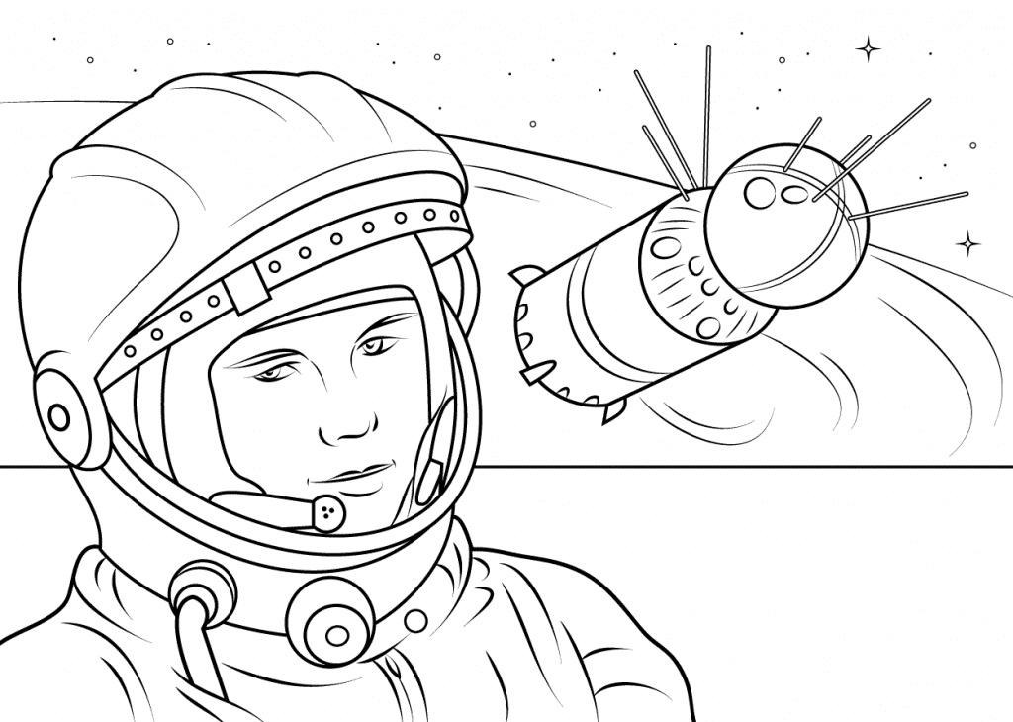](https://raskrasil.com/wp-content/uploads/Raskrasil-kosmos-100.jpg)

Юрий Гагарин

